aic
Accredited by the American College of Radiology

ADVANCED IMAGING CENTER
PHYSICIAN NEWS
www.advanced-imaging-center.com
March 30, 2011

INTERESTING CASE PRESENTATION

ARRHYTHMOGENIC RIGHT VENTRICULAR DYSPLASIA (ARVD)

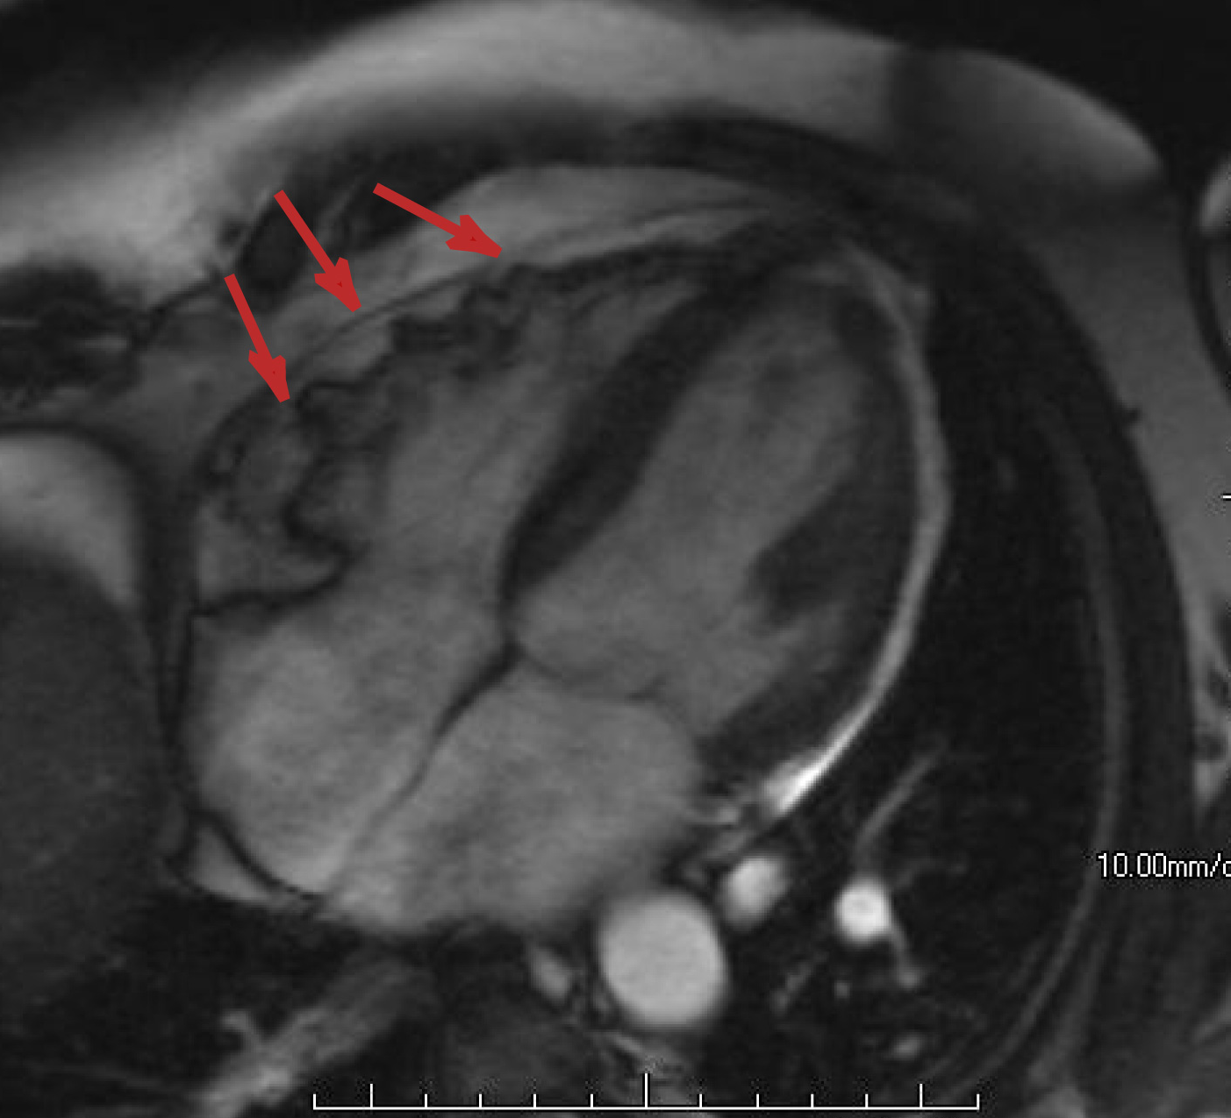
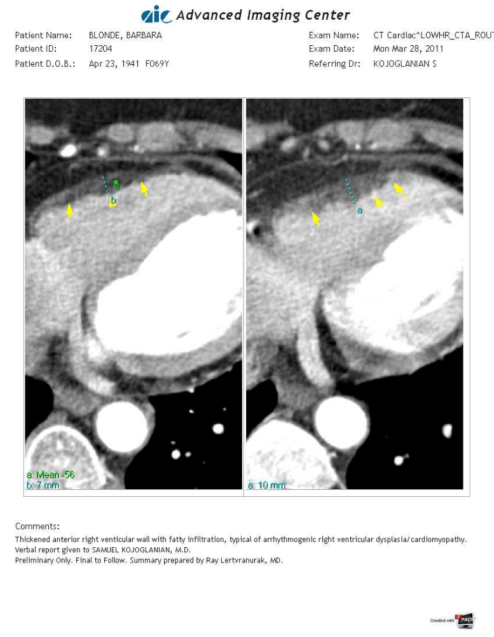
CLINICAL PRESENTATION: This is a 60-year old female who presented to Dr. Samuel Kojoglanian (Cardiologist in Valencia) with new onset arrhythmias and ventricular tachycardia noted on Holter. Echocardiogram findings were suspicious for Arrythmogenic Right Ventricular Dysplasia (ARVD). Therefore, the patient was referred to AIC-Valencia for a CT and MRI scans of the heart to rule out ARVD.

IMAGING FINDINGS: The CT images on the top left demonstrate a somewhat irregular and dilate right ventricle with an irregular, fatty-infiltrated wall. The image on the right is an MRI image on another patient (from the ACR’s case-in-point 3/30/2011). It shows similar findings and small aneurysms of the free wall.

DIAGNOSIS: Arrythmogenic Right Ventricular Dysplasia/Cardiomyopathy (ARVD/ARVC).

DISCUSSION: ARVD is a cardiomyopathy characterized by right ventricular arrhythmias. It can cause sudden death, particularly in young adults and athletes. It is usually familial due to a genetic defect resulting in atrophy of the right ventricular myocardium leading to fibrofatty replacement of the myocardium.
TREATMENT: The treatment options for ARVD include anti-arrhythmic agents, implanted cardiac defibrillator devices and ventriculostomy, catheter ablations, or a heart transplant as a last resort.
Please do not hesitate to call me with any questions.

Ray Hashemi, MD
Ray H. Hashemi, M.D., Ph.D.
Diplomat American Board of Radiology

